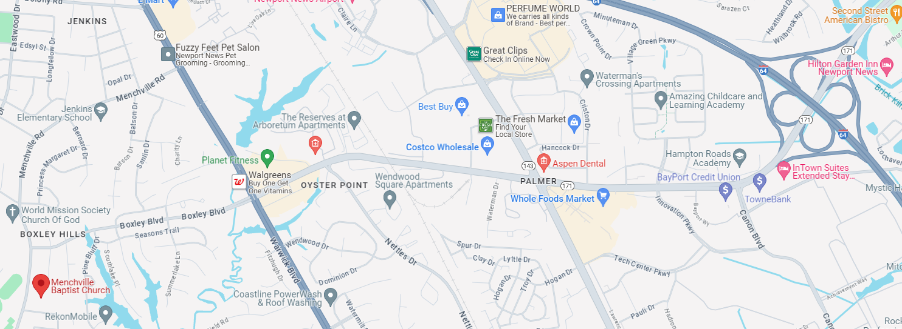
Take I-64 Exit 256A onto Oyster Point Road.
At Warwick Blvd road becomes Boxley Blvd.
At end of road turn left onto Menchville Rd – Church is on the left.

